**Experiment 9:**

**AIM:**

* Create table student with attributes id, name and department.
* Display
* Create view and select
* Insert values
* Create view with check option
* Insert values and alter table.

**SOLUTION:**

create table students(studno integer, stu_name varchar(20), dept varchar(20));

desc students;

create view stud_view as select studno,stu_name,dept from students;

select * from stud_view;

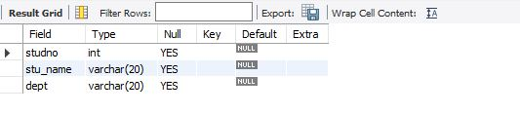

insert into stud_view values(555,"sahithi","cse");

insert into stud_view values(547,"sindhu","cse");

insert into stud_view values(525,"aradya","cse");

alter view stud_view as select studno,stu_name,dept from students where studno = 555;

create view stud_view as select studno,stu_name,dept from students with check option;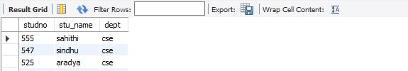

insert into stu_view values("556","varshitha","cse");

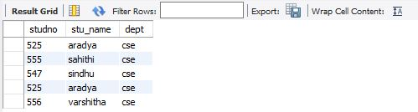

alter view stud_view as select studno,stu_name,dept from students where studno = 556;

drop view stud_view;

delete from stud_view where studno = 555;

